**October is National Domestic Violence Awareness Month**

October is National Domestic Violence Awareness Month, a time to raise awareness about the facts and warning signs of domestic abuse and how to help those experiencing abuse by a partner, family member or someone else close to them.

Faith communities can play a role during National Domestic Violence Awareness Month – and beyond by:

* Offering education sessions on sexual and domestic violence so congregants can respond safely and effectively when someone asks for help.
* Leading youth group sessions on healthy relationships, free from abuse and controlling behaviors
* Creating a congregational domestic violence response team
* Identifying resources from within your faith or denomination that are available for domestic abuse survivors
* Stocking your congregational library with domestic and sexual violence information, books and videos
* Publicizing local, state and national domestic abuse hotline numbers through programs, newsletters and posters
* Partnering with other congregations, schools, law enforcement and sexual and domestic violence advocates to present programming during Sexual Assault Awareness Month in April and Domestic Violence Awareness Month in October. (See www.nsvrc.org or www.ncadv.org for resources.)

Source: Safe Havens Interfaith Partnership Against Domestic Violence and Elder Abuse (www.interfaithpartners.org)

***Prayer****: We ask for continued courage to stand against all forms of oppression and violence in our world. Help us to assist women, men and children who are suffering abuse in their own homes with finding safety and hope for a better future.*





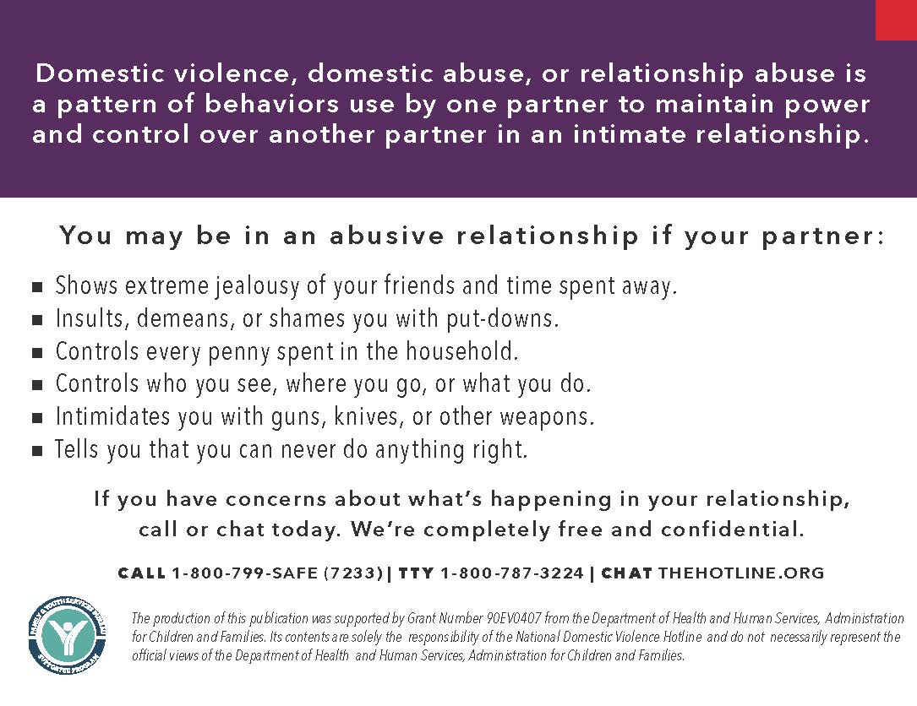

10/2020