

**Stroke is Preventable**

**What Is a Stroke?**

Stroke occurs when a blood vessel bringing blood and oxygen to the brain gets blocked or ruptures and brain cells don’t get the flow of blood that they need.

**Commit to Living Well**

Research has shown that you can reduce your stroke risk by living a healthy lifestyle. That means:

* Manage your blood pressure and diabetes
* Live tobacco-free
* Eat a low-fat, low-cholesterol diet
* Be physically active
* Maintaining a healthy body weight
* Drink little to no alcohol

**Stay Connected**

People who are socially isolated may face a 30 percent higher risk of heart disease and stroke than those who are socially connected, according to a recent study. This level of influence on heart health is on par with other risk factors such as anxiety and job stress.

**Be Hopeful!**

Sometimes stroke happens even when we do everything we can to be healthy. Do not despair. Stroke recovery is hard work but it is possible. The care that we provide to each other in our congregations is a vital part of the healing process. So take good care of the body that God has gifted you with and take care of each other, too!

*Thank you, God, for our amazing bodies. Help us nourish them with good food, exercise and loving relationships.*

5/2019



**Know the Signs of Stroke**

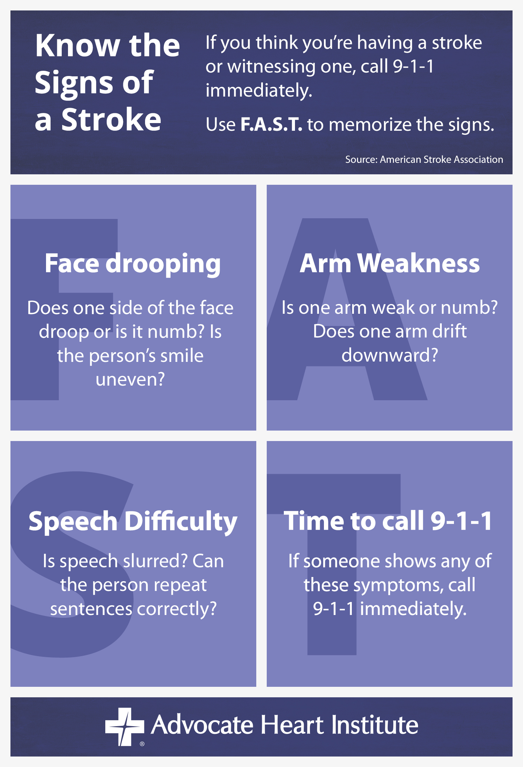

1/2019