**Martin Luther King, Jr. Day of Service: January 18**

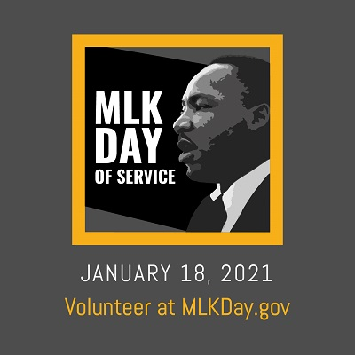

Dr. Martin Luther King Jr. lived his life serving others. You and members of your faith community can celebrate the Civil Rights leader’s life by serving on Martin Luther King Jr. Day of Service on Jan. 18—and beyond. By doing so, you help bring to life Dr. King’s vision of neighbors working together to build a better future.

To stay safe during the pandemic, make sure you wear a mask and stay at least six feet apart from others when volunteering. You also can participate in virtual and remote opportunities. Ideas include:

* Knitting hats and scarves for those facing homelessness
* Creating fleece blankets for families in need
* Hosting a virtual discussion on Dr. King’s life and teachings and his principles of non-violence
* Bringing meals to homebound neighbors
* Organizing a blood drive
* Removing graffiti from a building and painting a mural
* Distributing smoke detectors and fire safety information
* Making and distributing disaster preparedness kits
* Shoveling elderly neighbors’ walkways, clearing leaves or helping with other yard maintenance
* Helping job seekers create a resume, complete a job application or research training programs

***Prayer:*** *Thank you for the leadership and vision of Martin Luther King, Jr. in the struggle for equality and dignity for all human beings. Help us to listen to his words. Grant us the courage and strength to live out our commitment to create peace and justice in our world.*



12/2021

**The Benefits of Volunteering**

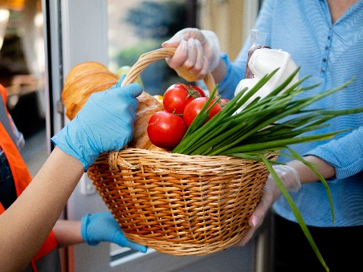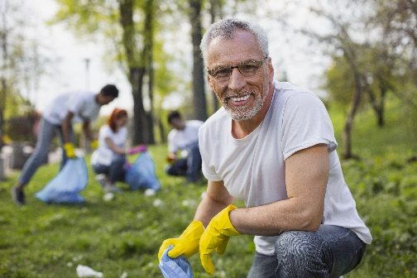

**Find volunteer opportunities:**

**MLKDay.gov**

**nationalservice.gov**

**pointsoflight.org**

According to recent figures, volunteers provided approximately $187.7 billion in services throughout the U.S. in 2019. Without these volunteers, many non-profit organizations would not be able to stay afloat.

While volunteering helps these organizations, researchers have found that being a volunteer offers many additional benefits:

* People who volunteer in general are happier because they feel they are part of something bigger. Their own lives have a purpose that is bigger than themselves.
* Volunteers say they feel better physically, mentally and emotionally.
* Volunteers feel a deeper connection to their community and to others.
* Volunteers experience less stress and worry.
* Volunteers who serve with the purpose of helping others live longer.
* Volunteers over the age of 50 are less likely to develop high blood pressure.