**February is African American History Month**

African American History Month takes place each February. It’s a time to celebrate the achievements and contributions African Americans have made throughout our country’s history.

You and your faith community can commemorate African American History Month in a variety of ways.

For example, you can:

· Participate in virtual celebrations and events taking place in your community

· Support an African American business

· Host an African American film marathon

· Read a book by an African American author

· Cook a soul food meal

· Learn about an unsung hero of Black history

· Study the African Diaspora

· Call out racism and prejudice in your community

· Sign up to receive news from an African American organization

· Read Dr. King’s “I Have a Dream” Speech

· Read a biography of an influential Black figure

· Register to vote

***Prayer:*** *Thank you for the gifts, accomplishments and witness of our African-descent neighbors and friends. Guide us as we commit ourselves to the work of racial justice, reconciliation and ending racism. May we stand together as partners, doing your work in the world together.*



2/2021

**February is African American History Month**

Historian and author Dr. Carter G. Woodson and other prominent

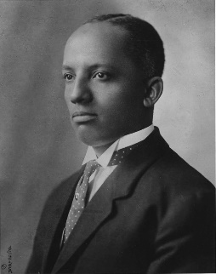African Americans first conceived of the idea for African American History Month in 1926, when they organized a Negro History Week to take place in the week of February that coincided with the birthdays of Abraham Lincoln, who issued the Emancipation Proclamation, and Frederick Douglass, the African American orator and abolitionist.

**Woodson**

Since 1976, every U.S. president has officially designated the month of February as African American History Month. It allows us to pause and remember the countless contributions African Americans have made to our country over the decades and centuries, through law, the arts, religion, sports, politics, medicine, research, the Civil Rights movement and many other ways.

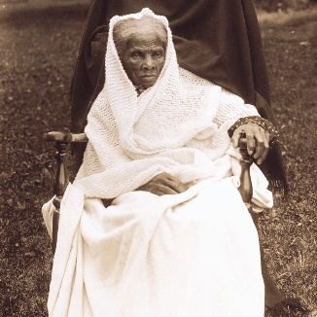

**Visit AfricanAmericanHistoryMonth.gov**

for exhibits, collections, audio, video, images and teaching resources.

