

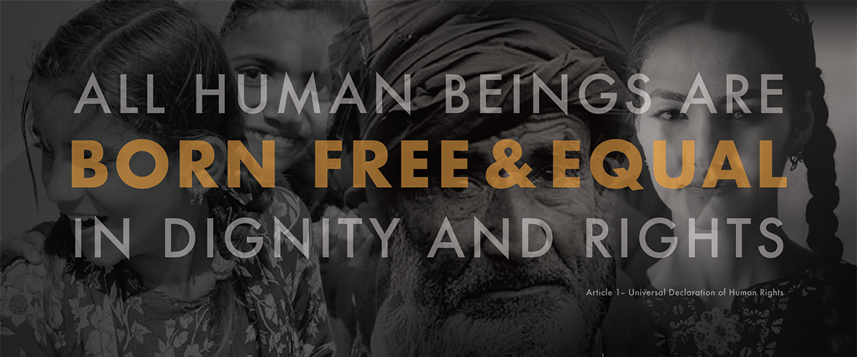**Observing Universal Human Rights Month**

December is Universal Human Rights Month – a time to reflect on the fundamental freedoms to which all human beings are entitled. Faith communities can observe Universal Human Rights Month in a number of ways:

* Read and reflect on the Universal Declaration of Human Rights document in bulletins and other communications (available at www.un.org/en/universal-declaration-human-rights/). The first article of the declaration makes clear its purpose:

*All human beings are born free and equal in dignity and rights. They are endowed with reason and conscience and should act towards one another in a spirit of brotherhood.*

* Offer volunteer or fundraising activities that benefit organizations that work for equality, justice and the dignity of all humans.
* Organize outings to exhibitions, festivals, museums, religious celebrations and other events. Reflect on how we all share one world with different cultures, faiths, beliefs and customs.

***Prayer****: I pray for those whose rights are ignored, violated or denied…for those who are displaced, abused and trafficked. Give me a deep desire for equality and dignity, and a commitment to human rights.*

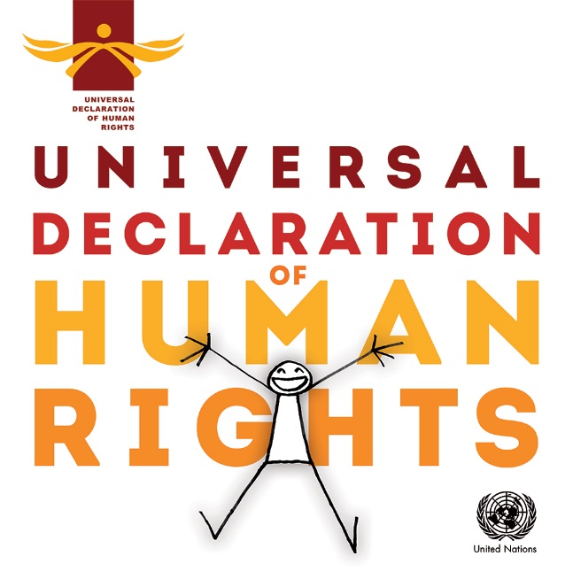

You can access the Universal Declaration of Human Rights document, as well as an illustrated version, at

www.un.org/en/universal-declaration-human-rights/

The website also features an audio recording of Eleanor Roosevelt reading the Declaration, historical photos and more.

The General Assembly of the United Nations adopted the Universal Declaration of Human Rights on Dec. 10, 1948.

It establishes the equal dignity and worth of every person, and sets out, for the first time, fundamental rights and freedoms to which all human beings are entitled, regardless of race, color, religion, sex, language, national or social origin, property, birth or other status. They include:

· Freedom from discrimination

· The right to equality

· The right to be considered innocent until proven guilty

The Universal Declaration of Human Rights Is the most translated document in the world, available in more than 500 languages.