C:\Users\wegehaupt_olga\AppData\Local\Microsoft\Windows\Temporary Internet Files\Content.Outlook\HZ42O8XJ\Advocate Aurora grey (002).jpg

**Get Your Zzzz’s to**

**Prevent Diabetes!**



Studies have shown that sleep is important to overall health. Now, researchers at the University of Colorado Anschutz Medical Campus and University of Colorado Boulder have found that a lack of sleep could also lead to an increased risk of diabetes.

The study found that not enough sleep leads to a reduction in the sensitivity to insulin, which impairs the ability to regulate blood sugar. A lack of sleep has been tied to weight gain, but with this new information sleep can also be equated to metabolism.

“Sleep is obviously an important piece in overall health,” says Lauren Saujani, nurse practitioner at Advocate Dreyer Medical Clinic in Aurora, IL. “This adds another piece to the puzzle for us to discuss with our patients and stress the importance of a total healthy lifestyle.”

Regulating blood sugar levels is a crucial component of monitoring diabetes. When people are sleep deprived, the body urges them to rest and as a result their body makes it more difficult to break down the food, causing a spike in blood sugar levels.

“Everything that goes into your body when you are diabetic can make a huge impact,” says Saujani. “While more research is needed, this study gives us a good insight on how we can help those who are at risk for becoming diabetic.”

***Prayer:*** *In our busy world, help us to value ourselves enough to rest*

*and take care of ourselves that we might live well.*

11/2018

C:\Users\wegehaupt_olga\AppData\Local\Microsoft\Windows\Temporary Internet Files\Content.Outlook\HZ42O8XJ\Advocate Aurora grey (002).jpg

**Diabetes and Heart Disease**

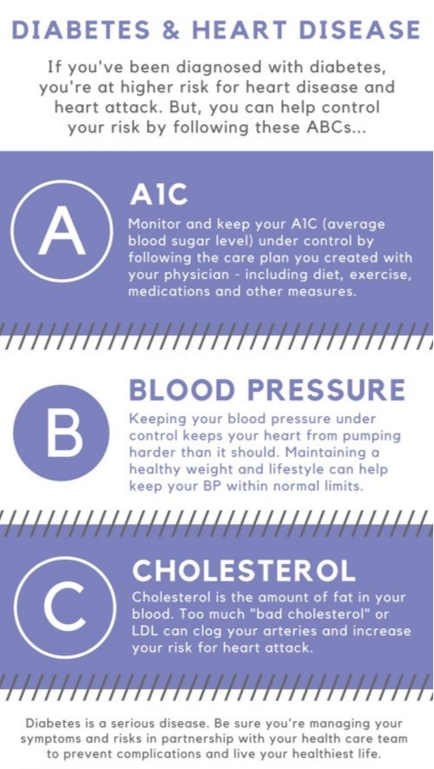

11/2018