

**March is National Nutrition Month**

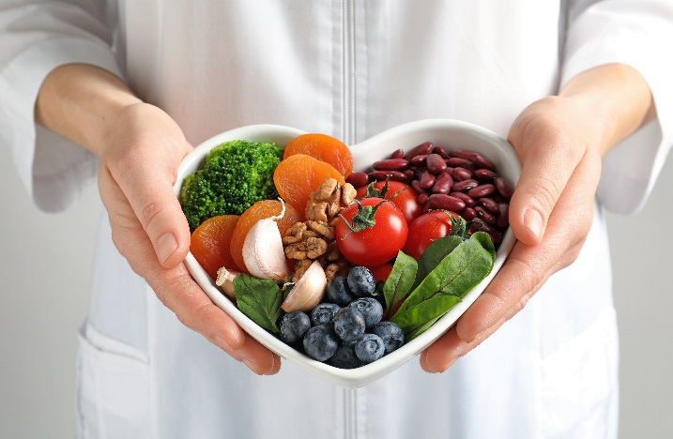National Nutrition Month provides the opportunity to focus on the importance of making informed food choices, and developing sound eating and physical-activity habits.

Eating a nutritious diet doesn’t have to be overwhelming. Small changes can have a cumulative effect. Some ways to get started include eating a variety of healthy foods every day, planning your meals each week, creating tasty meals at home and consulting a registered dietitian nutritionist.

Faith communities can get involved in National Nutrition Month in a variety of ways by:

* Examining communal food practices: Do food and fellowship opportunities in your congregation feature high calorie snacks? Add some nourishing options to the coffee hour menu, potlucks or children and youth meals.
* Hosting a session on nutrition and healthy eating.
* Planning a healthy fellowship meal, making sure each of the food groups is represented.
* Organizing a field trip to a farmers’ market or local farm.
* Publishing healthy recipes in your faith community newsletter, bulletin and other communications.
* Creating a congregational cookbook with nutritious, healthy recipes.

***Prayer****:* Thank you for the abundance of creation: the fruits, vegetables and grains that sustain and nourish us. Inspire us to make wise food choices in our homes and in our communities.

**To learn more, visit the Academy of Nutrition and Dietetics: www.eatright.org**



**National Nutrition Month** provides the opportunity to focus on the importance of making informed food choices, and developing sound eating and physical-activity habits.

Eating a nutritious diet doesn’t have to be overwhelming. Small changes can have a cumulative effect. Some ways to get started include eating a variety of healthy foods every day, planning your meals each week, creating tasty meals at home and consulting a registered dietitian nutritionist.

Faith communities can get involved in National Nutrition Month in a variety of ways by:

* Examining communal food practices: Do food and fellowship opportunities in your congregation feature high calorie snacks? Add some nourishing options to the coffee hour menu, potlucks or children and youth meals.
* Hosting a session on nutrition and healthy eating.
* Planning a healthy fellowship meal, making sure each of the food groups is represented.
* Organizing a field trip to a farmers’ market or local farm.
* Publishing healthy recipes in your faith community newsletter, bulletin and other communications.
* 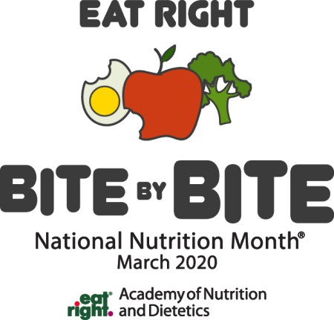Creating a congregational cookbook with nutritious, healthy recipes.