

**June is National Safety Month**

June is National Safety Month, a time set aside to focus on saving lives and preventing injuries, from the workplace to anyplace, including houses of worship.

The message on staying safe takes on great significance during this time of pandemic. The National Safety Council provides guidance to help faith communities safely reopen and welcome back congregants, visitors, and staff members.

**Guidelines include:**

* Fully sanitize your facility and equipment.
* Determine the maximum occupancy of your building. Limit the number of people in your building to ensure they can safely remain six feet apart.
* Establish procedures for proper disposal of face masks, gloves, and other disposable personal protective equipment.
* Use visual cues and signage that encourage physical distancing.
* Encourage frequent hand washing and make hand sanitizer available in several locations, especially near common touchpoints.
* Designate separate entrances and exits for buildings and rooms, and provide directional signage for traffic flow along with physical distancing reminders/cues.

**Prayer**: *During this time of pandemic, keep our families, neighborhoods and congregations safe. Continue to guide us in the days ahead. Be with us as we make plans to reunite and serve in and through our faith communities*.

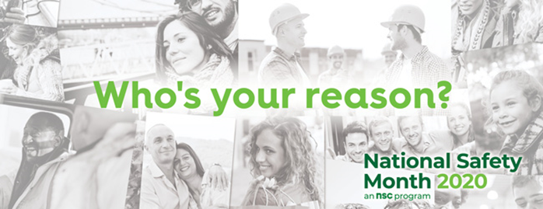

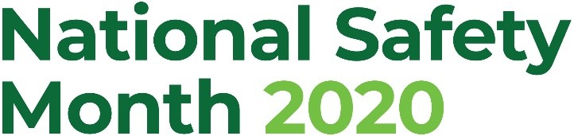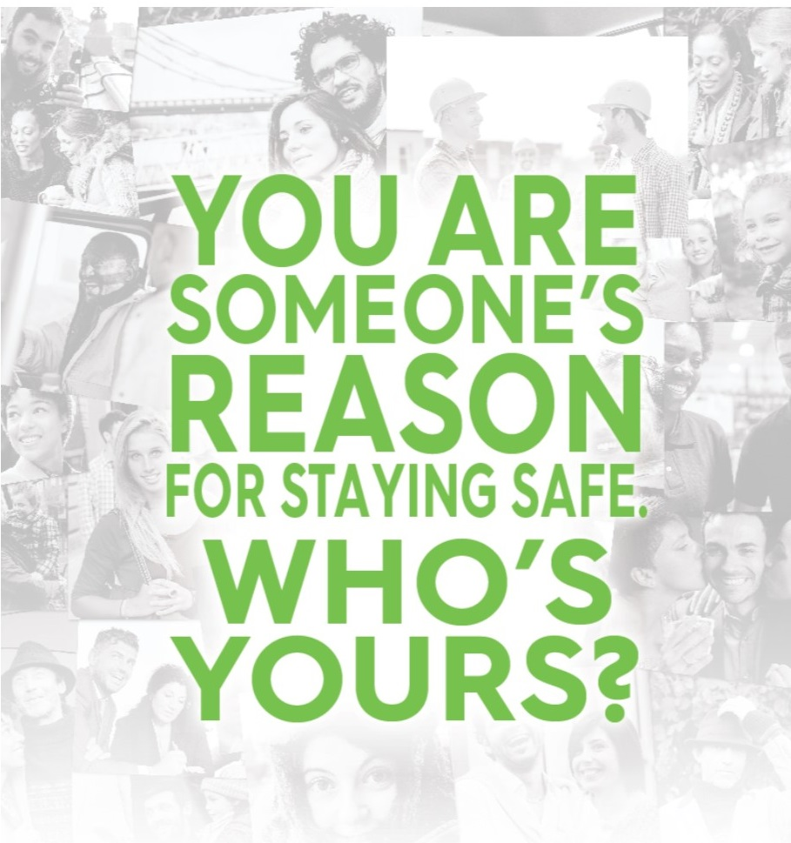

* **We are all someone’s reason for staying safe. Who is yours? A friend? Your partner, parent, son or daughter?**
* **Why is promoting and modeling safety a way to love your neighbor?**
* **In what ways can you ensure members of your community are safe? How can you get involved?**