

**February is American Heart Month**

Did you know that people who have close relationships at home, work or in their community tend to be healthier and live longer? One reason, according to the National Heart, Lung, and Blood Institute (NHLBI), is that we’re more successful at meeting our health goals when we join forces with others.

**Why Connecting is Good for Your Heart**

Feeling connected with others and having positive, close relationships benefit our overall health, including our blood pressure and weight. Having people in our lives who motivate and care for us helps, as do feelings of closeness and companionship.

Follow these heart healthy lifestyle tips with your friends, family, coworkers, and others in your community and you’ll all be heart healthier for it:

➢ Be more physically active.

➢ Maintain a healthy weight.

➢ Eat a nutritious diet.

➢ Quit smoking.

➢ Reduce your stress.

➢ Get enough quality sleep.

➢ Track your heart health stats.

You don’t have to make big changes all at once. Small steps will get you where you want to go.

***Prayer****: Prayer: Thank you for the gift of community. Help me to encourage and support others. Inspire us all to care for one another and our own health.*

**To learn more, visit the National Heart, Lung and Blood Institute:**

**www.** **https://www.nhlbi.nih.gov**



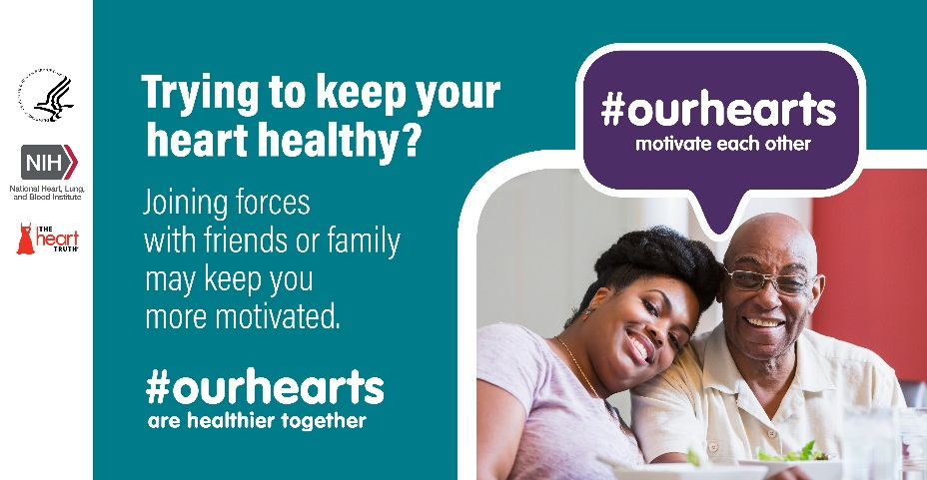

**Celebrate American Heart Month Together**

**Move More:** Invite members of your faith community to join you in your efforts to be more physically active. For example, walk together on a regular basis or join an exercise class at your local community center.

**Aim for a healthy weight:** Find someone in your faith community who also wants to reach or maintain a healthy weight. Do healthy activities together, like walking or playing on a neighborhood sports team. Share low-calorie, low-sodium meals or recipes.

**Quit smoking:** To help you quit, ask others for support or join a support group. Research shows that people are much more likely to quit if their spouse, friend, or sibling does.

**Manage stress:** Join with a friend or family member to do a relaxing activity every day, like walking, yoga, or meditation, or participate in a stress management program together.

**Improve sleep:** Family members and friends: remind each other to turn off the screen and stick to a regular bedtime. Instead of watching TV before bed, relax by listening to music, reading, or taking a bath.

**Track your heart health stats, together:** Keeping a log of your blood pressure, weight goals, physical activity, and if you have diabetes, your blood sugars, will help you stay on a heart healthy track. Ask your friends or family to join you in the effort.