**August is National Immunization Awareness Month**

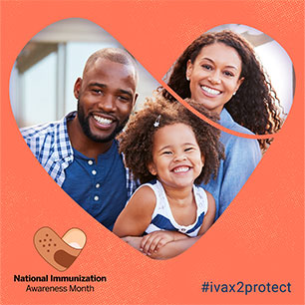National Immunization Awareness Month is an annual observance that highlights the importance of getting recommended vaccines throughout your life.

Advocate Aurora Health encourages you talk to your doctor, nurse or other healthcare professional to ensure you and your family are up to date on recommended vaccines.

**During National Immunization Awareness Month, your faith community can:**

* Encourage members to get their flu shot. The Centers for Disease Control (CDC) recommends every person six months and older receive an annual flu vaccine. See the CDC Flu Vaccine Finder and other information at <https://www.cdc.gov/flu>.
* Offer your building as a flu vaccination site. Remember to follow CDC safety guidelines to prevent the spread of COVID-19. Learn more at <https://tinyurl.com/r3dcpqk>.
* Organize rides to vaccination clinics or set up vaccination appointments for seniors, those with disabilities and other members in need of assistance.
* Hold an information session on vaccines or publicize the CDC vaccine guide in your faith community newsletter or website: <https://tinyurl.com/y3kyo25p>.

***Prayer****: Thank you for the protection we receive through immunization. Strengthen and guide us as we care for ourselves and those with whom we share our world.*



8/2020

**You Have the Power to Protect**



If you are pregnant, getting vaccinated can help protect your baby after birth by passing on antibodies. These antibodies can give your baby short-term protection from flu and whooping cough until it is time for their own vaccines.

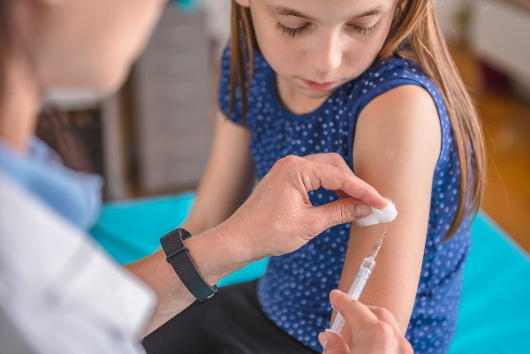

Adults: Vaccines aren’t just for kids. You may need vaccines to protect against whooping cough, flu, pneumonia, and shingles. Ask your doctor about vaccines you may need for your age, health conditions, job, or lifestyle.

Parents: You have the power to protect your children against serious diseases like measles, cancers caused by HPV, and whooping cough. View CDC’s immunization schedule to see which vaccines your children need, whether they are babies or teenagers: https://tinyurl.com/y8b2ocvf

**For more information, visit:**

**https://www.cdc.gov/vaccines/events/niam/index.html**