**April 16:**

**National Health Care Decisions Day**



**National Health Care Decision Day takes place on April 16.**  It’s a day designed to inspire, educate, and empower the public and providers about the importance of advance care planning.

Advance care planning is an important step to ensure you get the medical care you would want if you cannot speak for yourself and doctors and family members are making the decisions for you. Advance care planning is a process that can begin with a conversation with your family and other loved ones.

During your conversation, you can share your wishes, such as:

· who you’d like to make care decisions for you when you can’t;

· the types of medical treatment you want or don’t want;

· how comfortable you want to be;

· how you want people to treat you, and

· what you want your loved ones to know.

Advance care planning can allow you communicate what is most important to you and provides a firm foundation for your care plan and goals moving forward.

**Prayer**: *Thank you for the comfort and peace of mind advance care planning provides. Guide us in our conversations and plans so we may be able to carry out our loved one’s wishes and values with certainty and clarity.*



4/2021

**Advance Care Planning:**

**Carrying out a person’s wishes**

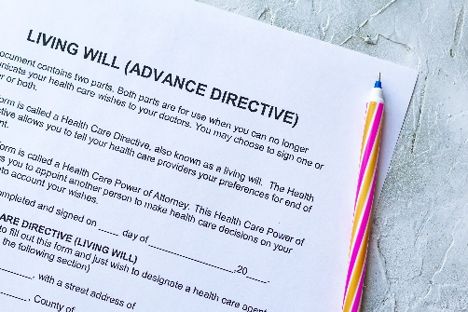

There are two main elements in an advance directive:

**Living will**: a written document that helps you tell doctors how you want to be treated if you are dying or permanently unconscious and cannot make your own decisions about emergency treatment.

**Durable power of attorney for health care**: a legal document naming someone to make medical decisions for you at times when you are unable to do so.

Other advance care planning documents include Do Not Resuscitate orders and organ and tissue donation.

**Learn more:** [**tinyurl.com/342apsxa**](https://www.nia.nih.gov/health/advance-care-planning-health-care-directives)

**5 Simple Starting Steps**

1. Decide you want to do this and will complete it.

2. Consider who you would want to help discuss health conditions or make decisions for you if you are unable.

3. Think about how aggressively you want to seek to maintain your health. Choices include: do everything; do less aggressive and not heroic treatments; or use treatments only for comfort.

4. Document your wishes and priorities.

5. Share these thoughts with your loved ones and medical provider. [Courtesy Penn Medicine Lancaster General Health](https://www.lancastergeneralhealth.org/health-hub-home/2021/january/having-an-advance-care-plan-is-always-important-especially-now)

