We Can Be a Voice for Acceptance
and Access

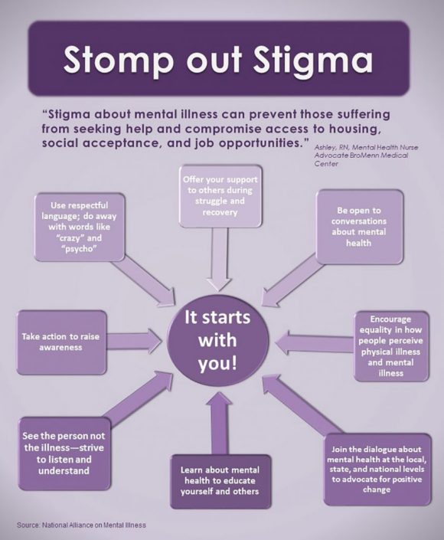

Prayer: Dear God, it starts with me! Let me be your instrument to prevent the suffering of people with mental illnesses and their families. Amen.

5/2018

Coping with Mental Illness
in Your Family

Mental illnesses are very common, but most families are not prepared to cope with news that a loved one has a mental illness. It can be draining, and family members may feel vulnerable to the judgments and opinions of others. You need to know there is help—and hope—for recovery from mental illness.

Three Ways Family Members Can Stay Healthy

1. Accept your feelings. Avoid placing blame or feeling guilt. You did not cause the illness, and the person diagnosed didn’t either. You may deny signs and symptoms of mental illness or fear what others are thinking, but you must accept that these feelings are normal. A mental health professional can help you cope with your feelings, so you can be supportive to your loved one diagnosed with the illness.

2. Take time for yourself. When family members are ill, they can easily become the focus of your attention. Other family members may feel neglected and become resentful. Try to keep a balance and maintain your regular family functions. If you are the caretaker, plan activities for yourself and with other family members so that you can keep perspective and patience.

3. Seek support. Gather information from reliable sources, such as mental health professionals, and share what you have learned with others. Getting support from friends and family members who can provide compassion without judgment is helpful, but support from community organizations is, too. The National Alliance on Mental Illness (NAMI) and the Depression and Bipolar Support Alliance offer support and education classes specifically for family members to learn about mental illness and how to care for themselves and their loved ones.
4. Practice your faith. Spiritual practices help to ground us in God’s love and care, connect us to others, provide stability and rhythm in our lives and reduce stress. It can be tempting to withdraw when dealing with mental illness, but the support of your fellow congregation members can a vital part of staying well

5/2018

