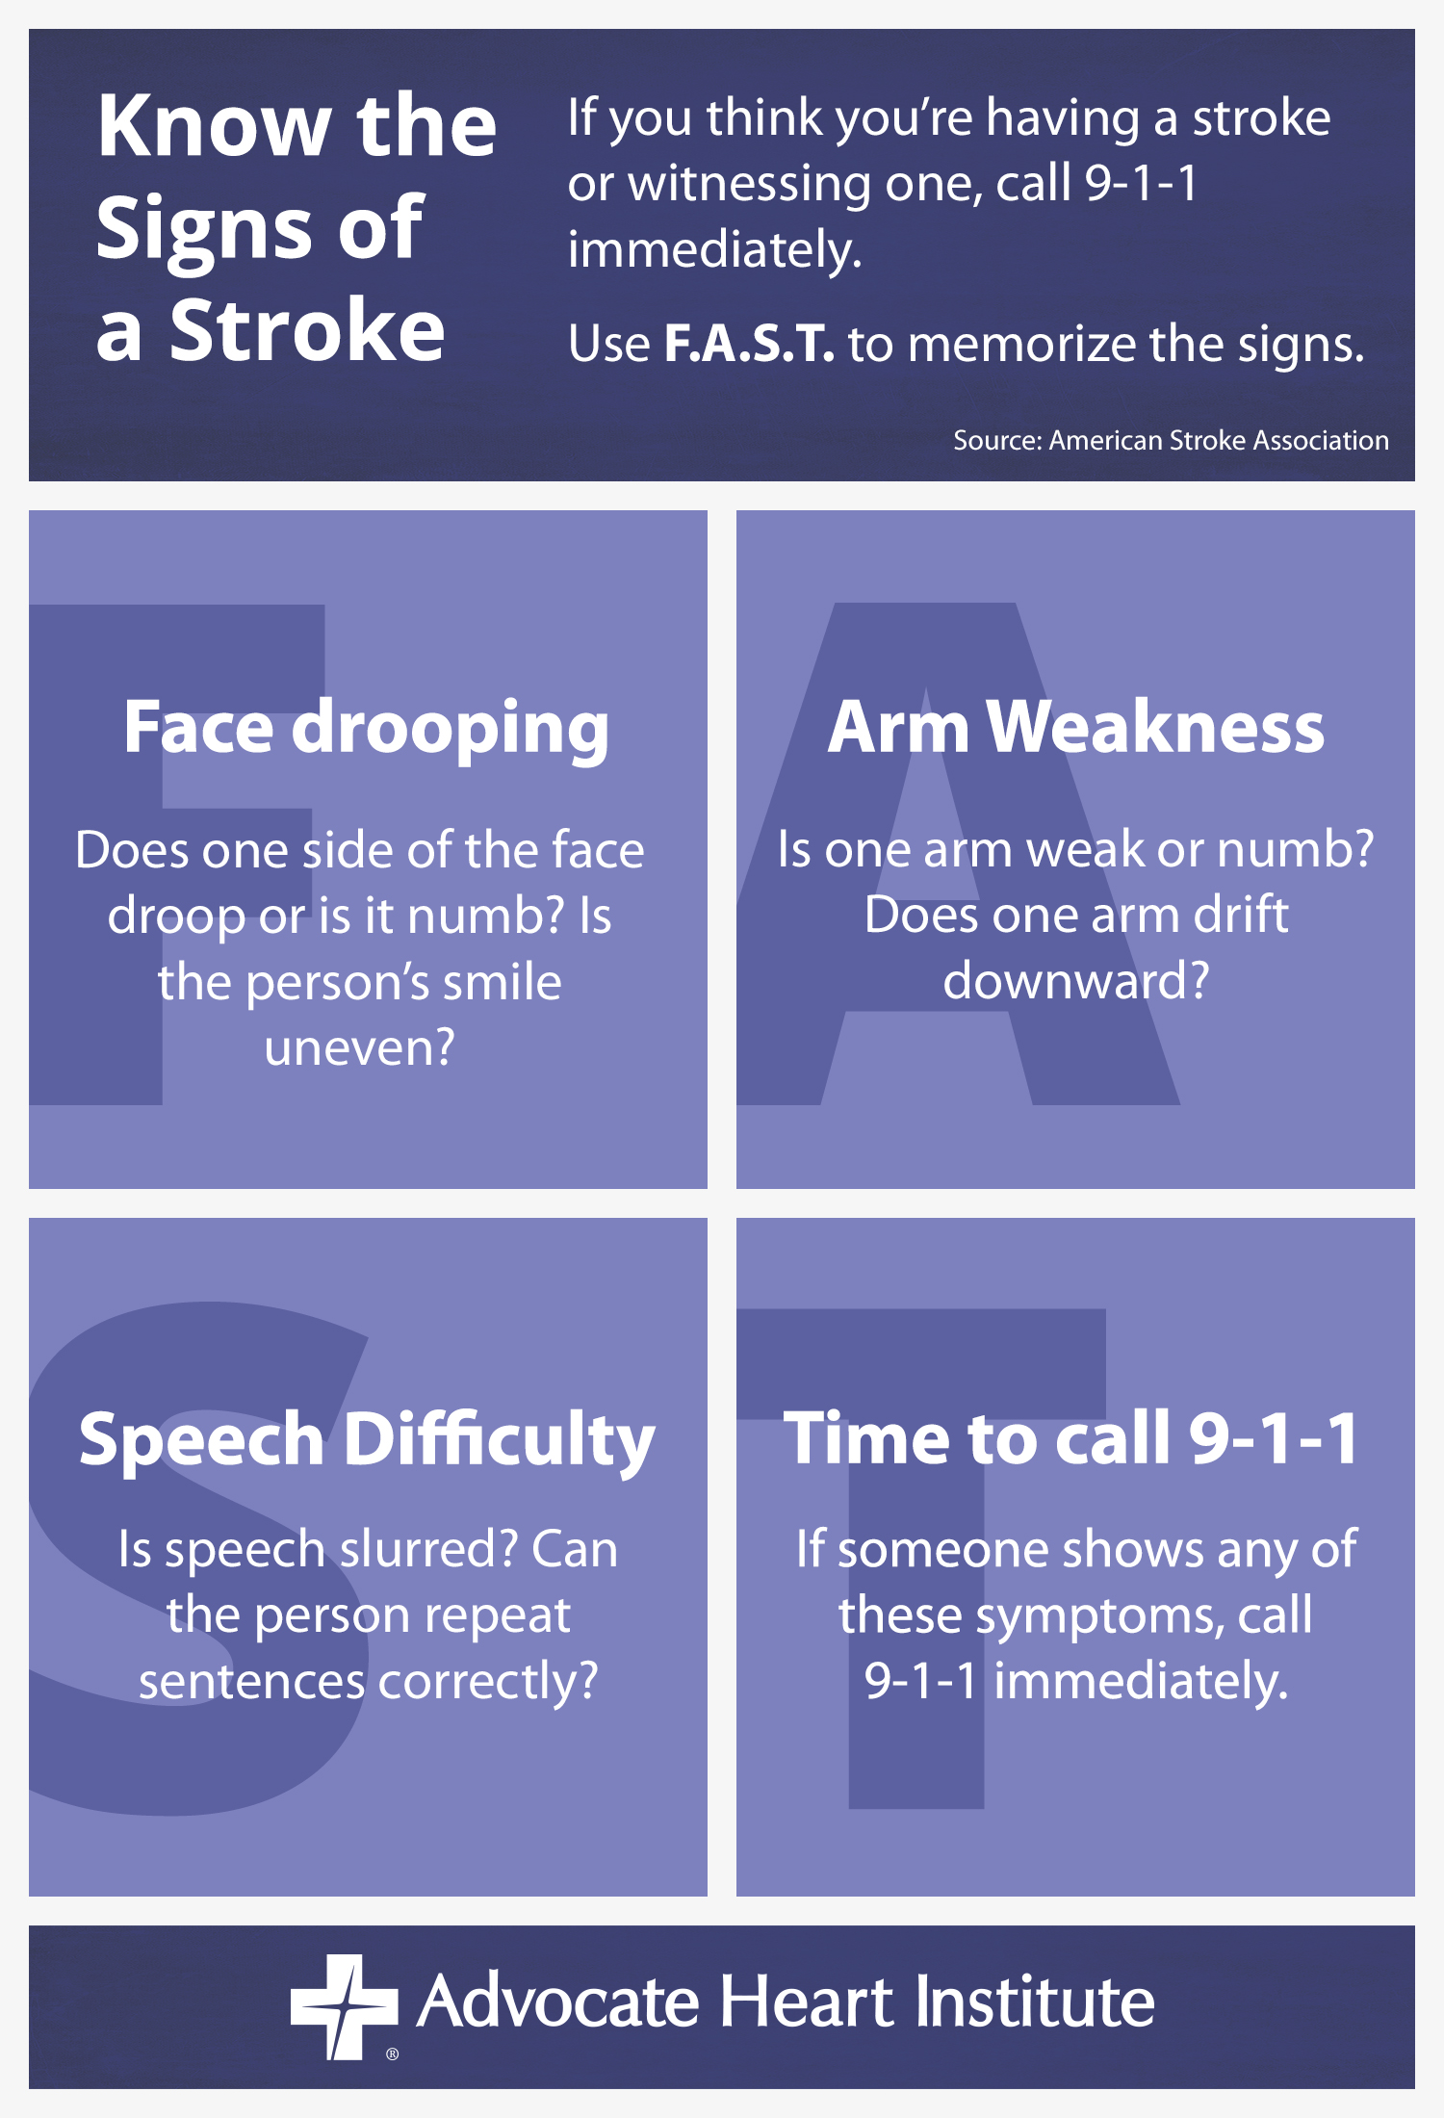1/2018

Things to know about Stroke

What Is a Stroke?
Stroke is the fourth leading cause of death and a major cause of serious, long-term disability in America. It occurs when a blood vessel bringing blood and oxygen to the brain gets blocked or ruptures and brain cells don’t get the flow of blood that they need. Stroke affects people of all ages, ethnicities and backgrounds. Some people—specifically women, African Americans, people with high blood pressure and people with physical or cognitive disabilities—have a higher risk of stroke.

Know Your Risk Factors – Know Your Score
Did you know up to 80% of all strokes are preventable? Research has shown that you can reduce your stroke risk by living a healthy lifestyle — controlling high blood pressure; not smoking; eating a low-fat, low-cholesterol diet/being physically active; maintaining a healthy body weight; managing diabetes; and drinking little to no alcohol.

Stay Connected
People who are socially isolated may face a 30 percent higher risk of heart disease and stroke than those who are socially connected, according to a recent study. This level of influence on heart health is on par with other risk factors such as anxiety and job stress.

Be Hopeful!
Sometimes stroke happens even when we do everything we can to be healthy. Do not despair. Stroke recovery is hard work but it is possible. The care that we provide to each other in our congregations is a vital part of the healing process. So take good care of the body that God has gifted you with and take care of each other, too!

Prayer: Thank you, God, for our amazing bodies. Help us nourish them with good food, exercise and loving relationships.

1/2018

