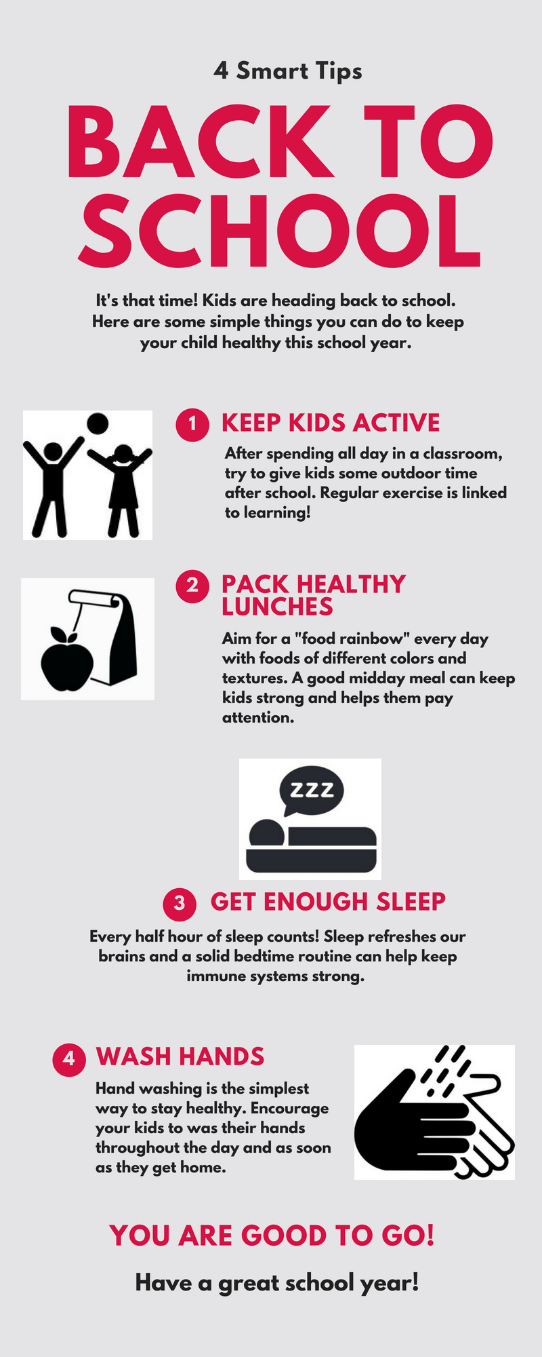

08/2018

Packing Up:
Prevent Backpack Injuries

Kids are carrying more than ever in their backpacks and the load is getting heavy! Backpack injuries are a real concern. Doctors treat at least 14,000 children each year with injuries related to heavy backpacks. Dr. Anisha Shetty, an Advocate Children’s Medical Group pediatrician, offers this advice for keeping your child’s back healthy:
- Watch. Encourage your child or teenager to tell you about numbness, tingling or discomfort in the arms or legs, which may indicate poor backpack fit or too much weight being carried.

- Ease. Watch your child put on or take off their backpack to see if it is a struggle. If the backpack seems too heavy for the child, have them remove some of the books and carry them in their arms to ease the load on their back.

- Act. Do not ignore any back pain in a child or teenager. Seek medical advice and care.

- Partner. Talk to the school about lightening the load. Team up with other parents to encourage changes.

- Strategize. Encourage your child to stop at his or her locker when time permits throughout the day to drop off or exchange heavier books.

- Invest. If your child has back pain that does not improve, consider buying a second set of textbooks to keep at home.

Prayer: God, our amazing bodies that you created can bear a lot and sometimes we pile on more than is good for us. Help us teach our children to care well for their bodies by being gentle with themselves.

08/2018

