Fitness has a positive impact on
children’s learning.

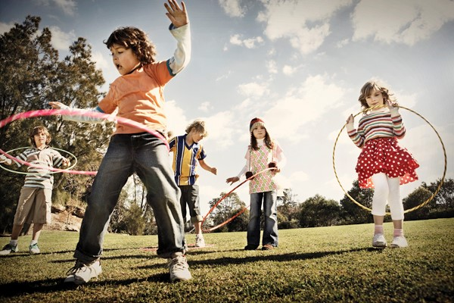

A new study has found that children who were the most physically fit scored significantly higher than the less fit group in memory exercises.

“One of the biggest reasons children have difficulty learning is due to a lack of concentration in the classroom,” says Dr. Joshua Alpert, Orthopedic Surgeon on the Medical Staff at Advocate Sherman Hospital in Elgin. “Physical activity helps them to release some of that built-up energy and reduces the monotony of sitting in class so they can more easily concentrate.”

How can you include time for exercise and physical activity in all of your programs for children? How can you celebrate their bodies and help them learn that moving their bodies is an important part of their spiritual lives?

A critical part of helping kids be active is doing the activity alongside them. So as adults, we are not off the hook! Keeping our kids healthy can help us, too!

Prayer: We are grateful, God, for the miracle of our bodies. We can move, we can stretch, we can flex! May we pass on this joy in our bodies to our children so that they may be healthy, happy and whole. Amen.

4/2018

Take Steps to
Improve Memory

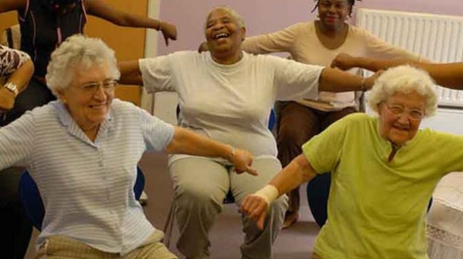

Exercise is key to mental health for older adults who are striving to remain independent and active. Older adults who walk or jog perform better on memory tasks than those who are more sedentary, according to researchers from Boston University.

The results showed that older adults who took more steps per day had better memory performance, including long-term memory.

The Boston University research showed that physical fitness benefits cognitive health or mental capabilities used to think, talk, learn, read and recall things from memory.

To maintain and improve brain health in older adults, Sue Durkin, geriatric advanced practice nurse at Advocate Good Samaritan Hospital in Downers Grove, says, “Our bodies were made to move. Many of these basic approaches to maintaining health and function can help sustain a satisfying quality of life.”

4/2018

